Google Cloud Build IaC
Integrate AccuKnox IaC scanning into Google Cloud Build to catch infrastructure misconfigurations before they hit production. The pipeline uses the AccuKnox ASPM Scanner CLI with Checkov, runs in three steps, and uploads findings directly to your AccuKnox CSPM panel.
Checkov scans Terraform, CloudFormation, Kubernetes manifests, Helm charts, Dockerfiles, ARM templates, and Serverless framework configs. Common findings include public S3 buckets, overly permissive security groups, missing encryption at rest, privileged containers, and missing resource limits.

Prerequisites
• GCP project with Cloud Build enabled
• AccuKnox SaaS access with permission to generate tokens
• A repository containing IaC files (Terraform, Kubernetes manifests, etc.) connected to Cloud Build
• A Cloud Build trigger pointing at the repository you want to scan

Steps for integration

Step 1: Generate an AccuKnox token
Log in to AccuKnox SaaS. Navigate to Settings, then Tokens and create a new token.
##Screenshot
Save these three values for use in Step 3:
Field | Where to find it
Endpoint | Your AccuKnox CSPM URL, for example, cspm.demo.accuknox.com
Token | The token string shown after creation
Label | Any descriptive string you choose

Step 2: Add the cloudbuild.yaml to your repository
Drop the following file at the root of your repository as cloudbuild.yaml.
# AccuKnox IaC (Checkov) — Google Cloud Build Pipeline

steps:

# ---------------------------------------------------------------------------
# Step 1: Validate required inputs (fail fast)
# ---------------------------------------------------------------------------
- id: validate-inputs
name: ubuntu:24.04
entrypoint: bash
env:
- ACCUKNOX_ENDPOINT=${_ACCUKNOX_ENDPOINT}
- ACCUKNOX_TOKEN=${_ACCUKNOX_TOKEN}
- ACCUKNOX_LABEL=${_ACCUKNOX_LABEL}
args:
- -c
- |
set -e
echo "Validating required inputs..."
if [ -z "$$ACCUKNOX_ENDPOINT" ] || [ -z "$$ACCUKNOX_TOKEN" ] || [ -z "$$ACCUKNOX_LABEL" ]; then
echo "ERROR: _ACCUKNOX_ENDPOINT, _ACCUKNOX_TOKEN, and _ACCUKNOX_LABEL must be set!"
exit 1
fi
echo "All required inputs present."

# ---------------------------------------------------------------------------
# Step 2: Download the AccuKnox ASPM Scanner CLI
# ---------------------------------------------------------------------------
- id: download-scanner
name: ubuntu:24.04
entrypoint: bash
args:
- -c
- |
set -e
export DEBIAN_FRONTEND=noninteractive
apt-get update -qq
apt-get install -y -qq --no-install-recommends curl ca-certificates

echo "Downloading AccuKnox ASPM Scanner v0.14.2..."
curl -sSL https://github.com/accuknox/aspm-scanner-cli/releases/download/v0.14.2/accuknox-aspm-scanner \
-o /workspace/accuknox-aspm-scanner
chmod +x /workspace/accuknox-aspm-scanner
echo "Scanner downloaded to /workspace/accuknox-aspm-scanner"

# ---------------------------------------------------------------------------
# Step 3: Install Checkov, run the IaC scan, upload to AccuKnox CSPM
# Install + scan run in the same step because ~/.local/bin/accuknox/ does not
# persist across Cloud Build steps — only /workspace is shared.
# ---------------------------------------------------------------------------
- id: run-iac-scan
name: ubuntu:24.04
entrypoint: bash
env:
- SOFT_FAIL=${_SOFT_FAIL}
- ACCUKNOX_ENDPOINT=${_ACCUKNOX_ENDPOINT}
- ACCUKNOX_TOKEN=${_ACCUKNOX_TOKEN}
- ACCUKNOX_LABEL=${_ACCUKNOX_LABEL}
- REPO_URL=${_REPO_URL}
- BRANCH_NAME=${BRANCH_NAME}
args:
- -c
- |
set -e

# Install ca-certificates so the scanner can upload over HTTPS
export DEBIAN_FRONTEND=noninteractive
apt-get update -qq
apt-get install -y -qq --no-install-recommends ca-certificates

# Install the IaC tool (Checkov) locally
# Required because we are not using --container-mode
echo "Installing IaC tool (Checkov)..."
/workspace/accuknox-aspm-scanner tool install --type iac

# Resolve soft-fail flag
SOFT_FAIL=$(echo "$$SOFT_FAIL" | tr -d ' \t\r\n')
SOFT_FAIL_ARG=""
if [ "$$SOFT_FAIL" = "true" ]; then
SOFT_FAIL_ARG="--softfail"
fi

# Optional repo-branch arg
REPO_BRANCH_ARG=""
if [ -n "$$BRANCH_NAME" ]; then
REPO_BRANCH_ARG="--repo-branch $$BRANCH_NAME"
fi

# Fallback for missing REPO_URL
if [ -z "$$REPO_URL" ]; then
echo "WARNING: _REPO_URL substitution is empty."
fi

# Run the IaC scan
echo "Running AccuKnox IaC scan..."
/workspace/accuknox-aspm-scanner scan --keep-results $$SOFT_FAIL_ARG iac \
--command "-d ." \
--repo-url "$$REPO_URL" \
$$REPO_BRANCH_ARG

# =============================================================================
# Substitutions
# _ACCUKNOX_ENDPOINT -> accuknox_endpoint (required)
# _ACCUKNOX_TOKEN -> accuknox_token (required)
# _ACCUKNOX_LABEL -> accuknox_label (required)
# _SOFT_FAIL -> soft_fail (optional, default "true")
# _REPO_URL -> repository URL (optional)
# =============================================================================
substitutions:
_ACCUKNOX_ENDPOINT: ""
_ACCUKNOX_TOKEN: ""
_ACCUKNOX_LABEL: ""
_SOFT_FAIL: "true"
_REPO_URL: ""

options:
logging: CLOUD_LOGGING_ONLY
machineType: E2_HIGHCPU_8

timeout: 1800s

Commit and push the file to your repository.

Step 3: Configure the Cloud Build trigger
Open Cloud Build in the GCP console. Create or edit a trigger pointing at your repository.
Under Configuration, select Cloud Build configuration file and point it at cloudbuild.yaml.
Under Advanced, then Substitution variables, add:
Variable name | Value
_ACCUKNOX_ENDPOINT | Your CSPM endpoint, for example, cspm.demo.accuknox.com
_ACCUKNOX_TOKEN | The token from Step 1
_ACCUKNOX_LABEL | A label of your choice, for example, iac-myapp
_REPO_URL | Your repo URL, for example, https://github.com/your-org/your-repo.git
_SOFT_FAIL | optional. true (default) or false to fail the build on findings

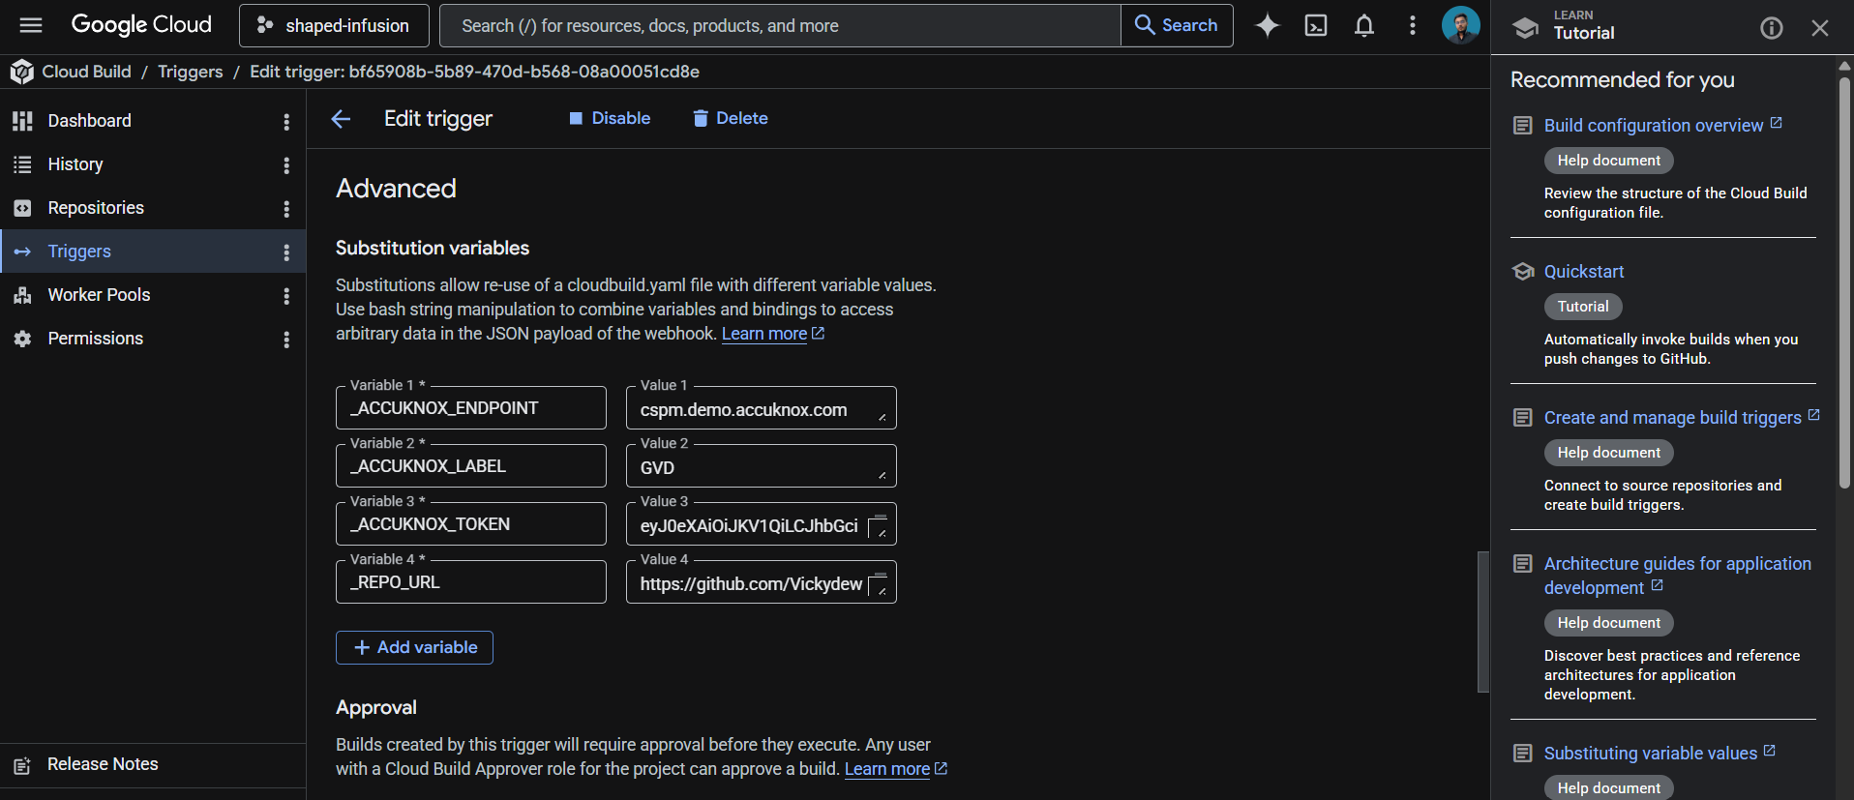
These values live in the trigger config rather than the YAML, which keeps your token out of git history.
Save the trigger. The next push to the watched branch runs the pipeline.

How the pipeline works
Step | Purpose
1. validate-inputs | Fails the build in under a second if any required substitution is empty. Saves a wasted scanner download when the token is missing.
2. download-scanner | Fetches the AccuKnox ASPM Scanner v0.14.2 binary into /workspace, which persists across Cloud Build steps.
3. run-iac-scan | Installs Checkov locally via the scanner CLI, runs the scan against the repo root, and uploads findings to AccuKnox CSPM.

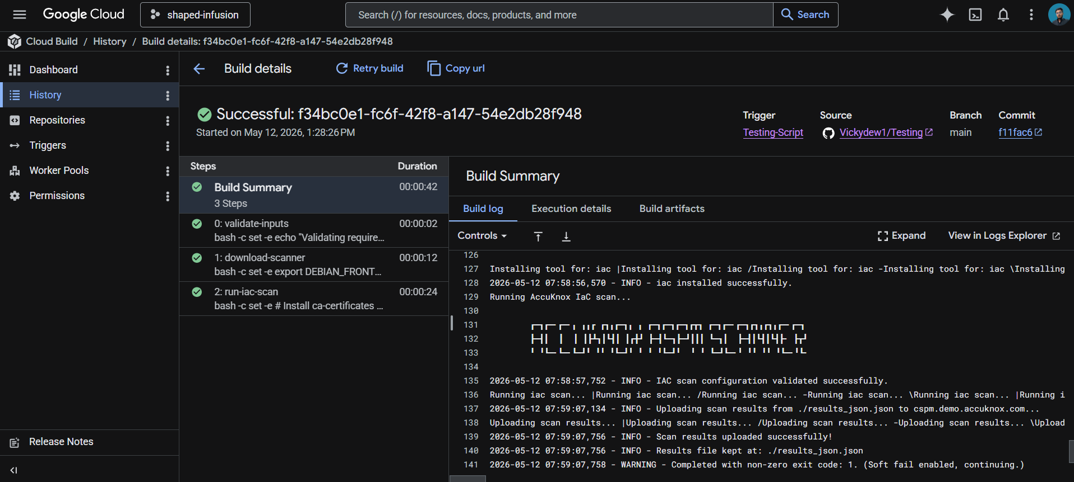

Viewing results
Open the AccuKnox CSPM panel. Filter findings by the label you set in _ACCUKNOX_LABEL. Each finding includes the file path, line number, Checkov rule ID, severity, and remediation guidance. Typical IaC findings include unencrypted storage, missing logging configurations, public network access, and missing IAM constraints.

Before the AccuKnox scan
Without IaC scanning in your pipeline, infrastructure misconfigurations only get caught after they're deployed (or worse, after they're exploited). Manual code review catches some issues, but humans miss things. Public S3 buckets, open security groups, and unencrypted databases routinely make it to production this way.

After AccuKnox scan integration
Once the pipeline above is wired up, every push triggers an IaC scan. Checkov flags misconfigurations like public buckets, missing encryption, overly permissive IAM policies, and Kubernetes containers running as root before the change merges. Findings appear in your AccuKnox CSPM panel with severity, file location, and remediation guidance, alongside your SAST, container, and DAST findings. Critical issues can fail the build by toggling _SOFT_FAIL to false.


